Using the below given two datasets you need to give a demo on the below joins in hive.

Bucket Map join

Sort-Merge Bucket join

Sort-Merge Bucket Map join

Left semi join

**Bucket Map join**

**Creating two tables and loading the data in these tables:**

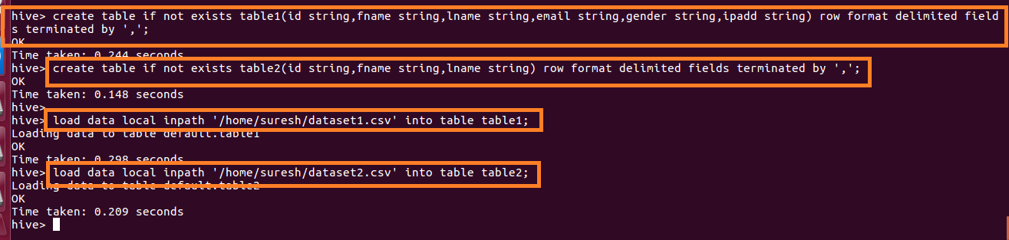

**Creating 2 bucket tables with 4 and 8 buckets:**

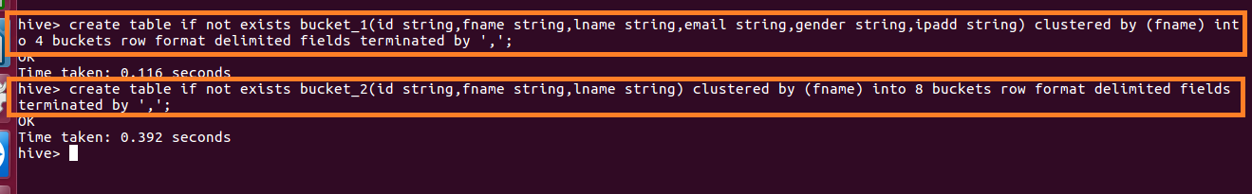

**Loading the data into bucket tables:**

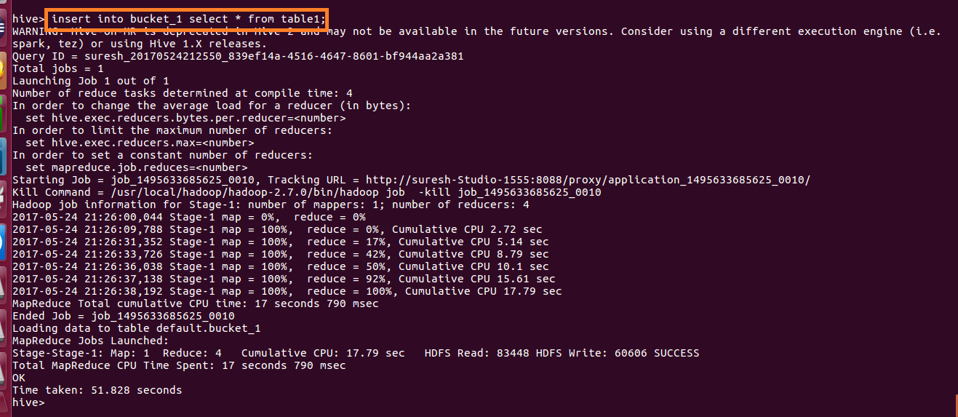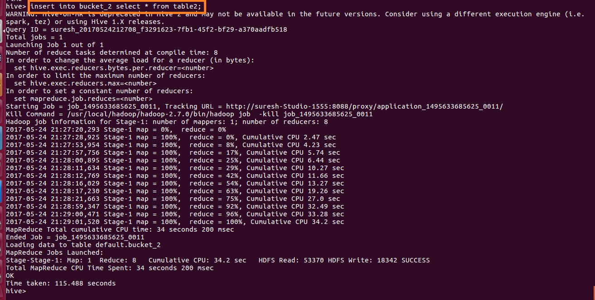

For performing Bucket-Map join, we need to set

set hive.optimize.bucketmapjoin = true and **writing query for bucket map join**

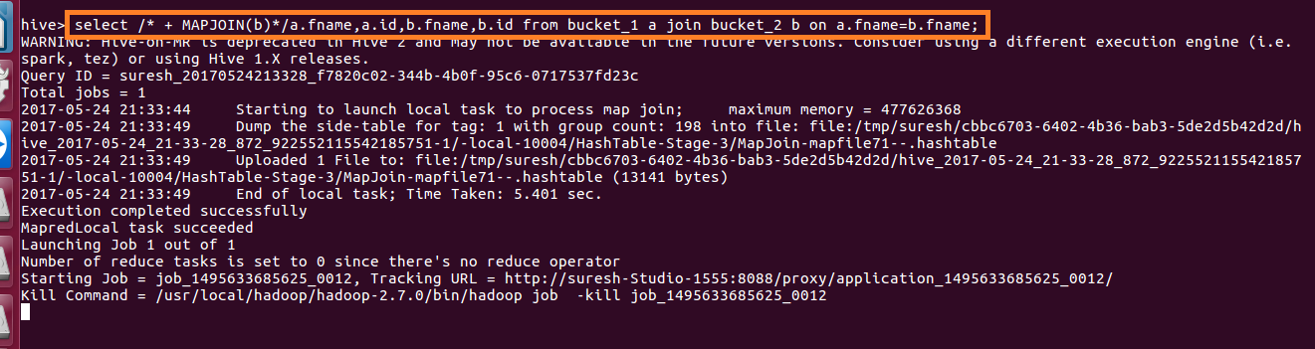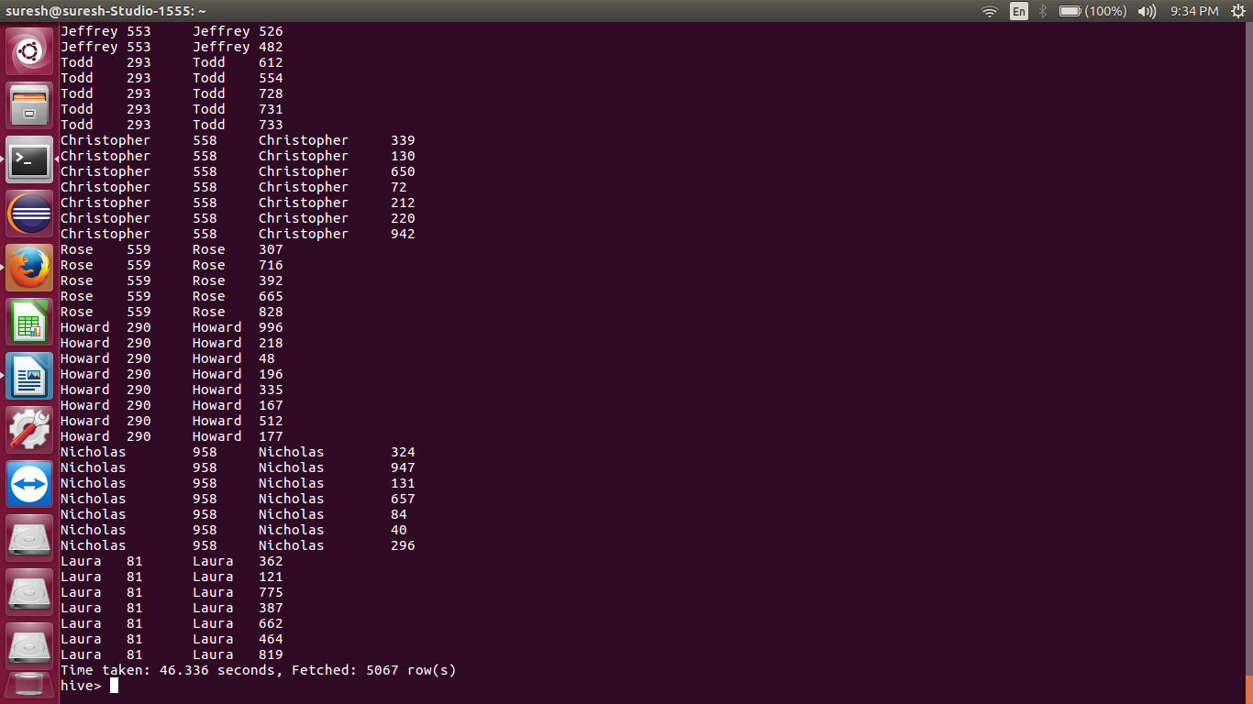

**Sort-Merge Bucket join**

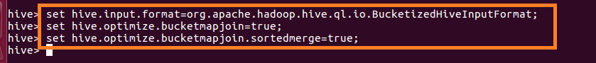

**Sorting the contents of bucket tables:**

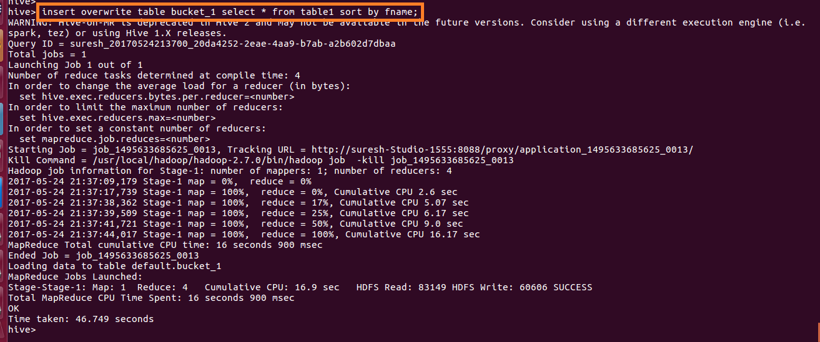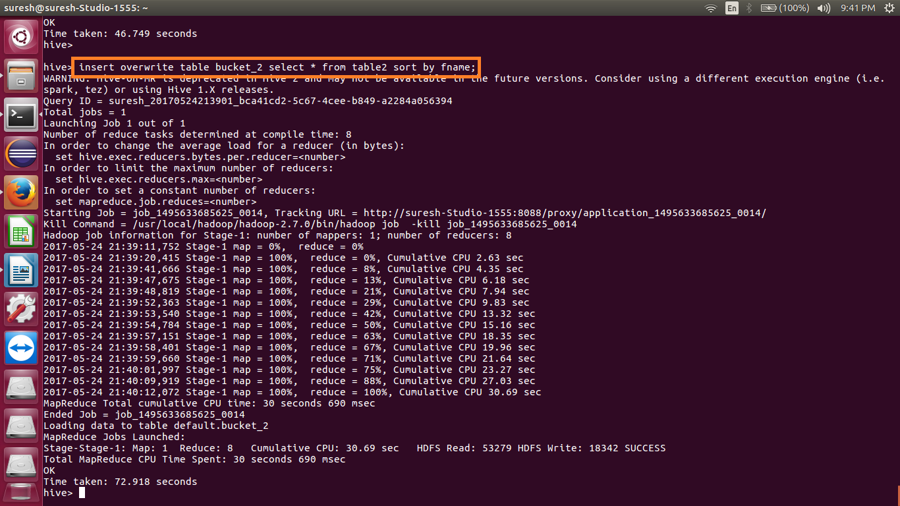

**Writing query for sort merge bucket join:**

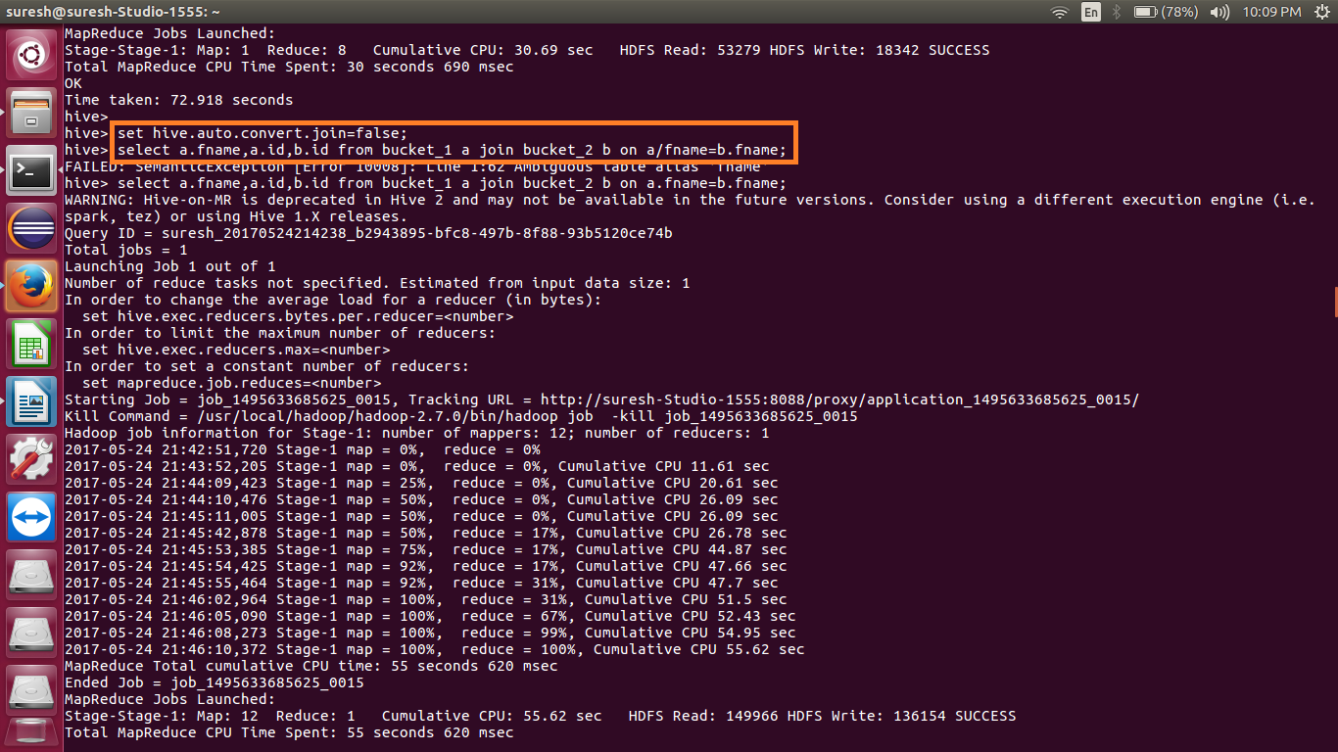

**Output:**

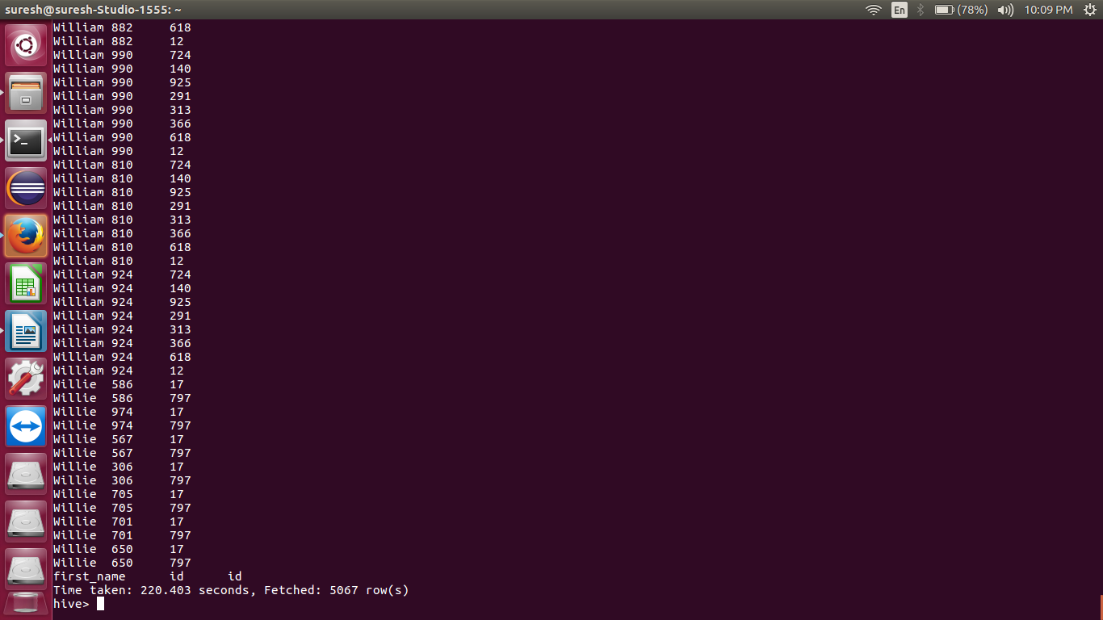

**SORT-MERGE BUCKET MAP JOIN:**

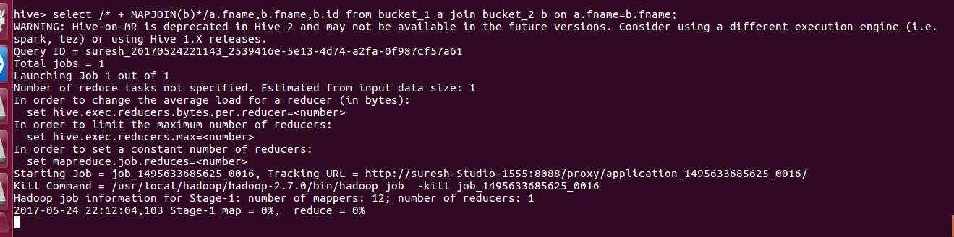

**Output:**

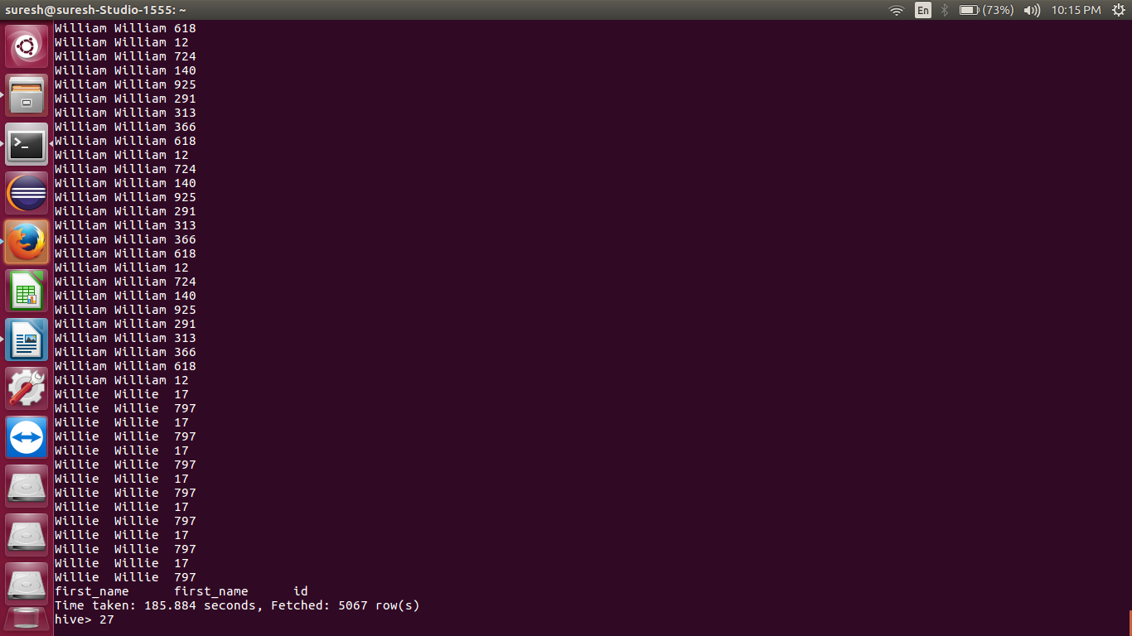

**Left Semi Join:**

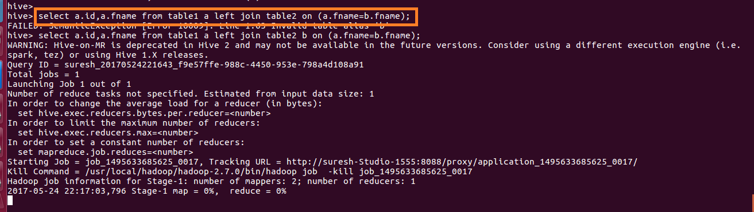

**Output:**

